Case Study Report



**Tech Saksham**

Data Analytics with Power BI

**“Real-Time Analysis of Bank Customers”**

**“College Name”**

|  |  |
| --- | --- |
| **NM ID** | **NAME** |
|  |  |

|  |  |
| --- | --- |
|  |  |
|  | Trainer Name |
|  | Master Trainer |

**ABSTRACT**

1.Data Collection: Gather data on unemployment rates in India from reliable sources such as government reports or databases.

2.Data Preparation: Clean and transform the data to make it suitable for analysis. This may involve handling missing values, removing duplicates, and formatting data types.

3.Data Modeling: Create a data model that includes the unemployment data and any other relevant datasets, or economic such as demographic or economic indicators.

4.Visualization: Use Power BI’s visualization tools to create charts and graphs that represent the unemployment situation in India. You can use line charts to show trends over time, bar charts to compare unemployment rates across different regions, and maps to visualize unemployment rates geographically.

5.Analysis: Use Power BI’s analytical capabilities to unemployment in India. You can use filters and slicers to analyze the data from different perspectives and identify patterns and trends.

6.Presentation: Finally, create a report or dashboard in Power BI that summarizes the key findings and insights about unemployment in India. Use visuals, text boxes and other elements to present the information in a clear and compelling way.

**INDEX**

|  |  |  |
| --- | --- | --- |
| **Sr. No.** | **Table of Contents** | **Page No.** |
| 1 | Chapter 1: Introduction | 1 |
| 2 | Chapter 2: Historical Data | 3 |
| 3 | Chapter 3: Current Scenario of Unemployment in India | 5 |
| 4 | Chapter 4: Unemployment of India in Pie Chart | 7 |
| 5 | Dashboard | 9 |
| 5 | Conclusion | 10 |
| 6 | Future Scope | 11 |
| 7 | Links | 12 |

**CHAPTER 1**

**INTRODUCTION**

## 1.1 The Current Unemployment Rate in India:

The unemployment rate witnessed a sharp decrease in January 2024. According to the latest data from the[Centre for Monitoring Indian Economy (CMIE)](https://www.cmie.com/kommon/bin/sr.php?kall=warticle&dt=20240202185251&msec=886), an independent think-tank, the unemployment rate in India stood at 6.8 percent in January. The unemployment rate in India saw a decrease of 1.9 percent in a month, as it stood at 8.7 percent in December last year.

Unemployment in the youth aged between 20 and 24 increased to 44.49 percent, which was 43.65 percent in the July-September quarter. Similarly, unemployment among the youth aged between 25 and 29 increased to 14.33 percent in the Oct-Dec quarter of 2023, which stood at 13.35 percent in the previous quarter.

[***1 USD to INR: From 1947 to 2023***](https://www.forbesindia.com/article/explainers/1-usd-to-inr-history/88635/1)***:***

On the other side of this coin is the uptick in Mudra loan disbursements, startup registration and an increased number of tax returns, which suggests a different picture of people choosing to be entrepreneurs and micro-entrepreneurs. The number of people engaged in self-employment, including unpaid household work or running a small business, increased to 57.3 percent in the period under review from 55.8 percent a year ago.

[***GDP of India: Current and historical growth rate, India's rank in the world***](https://www.forbesindia.com/article/explainers/gdp-india/85337/1)***:***

These changing trends in labour demand and employment rates call for thoughtful policy measures to address the prevailing economic challenges and ensure sustainable growth in rural and urban areas. It highlights the importance of diversifying economic activities to create more employment opportunities and bolster the country's financial resilience.

The recent weather patterns across the country have brought about significant changes in economic conditions. As the rains have covered large parts of India, impacting nearly half of the agricultural land, expectations of higher farm production have risen. This positive development has the potential to contribute to overall economic growth and improve the labour demand in the agriculture sector.

**CHAPTER 2**

**HISTORICAL DATA**

|  |  |
| --- | --- |
| **Year** | **Unemployment Rate (percent)** |
| 2024 | 6.57 (January 2024) |
| 2023 | 8.003 |
| 2022 | 7.33 |
| 2021 | 5.98 |
| 2020 | 8.00 |
| 2019 | 5.27 |
| 2018 | 5.33 |
| 2017 | 5.36 |
| 2016 | 5.42 |
| 2015 | 5.44 |
| 2014 | 5.44 |
| 2013 | 5.42 |
| 2012 | 5.41 |
| 2011 | 5.43 |
| 2010 | 5.55 |
| 2009 | 5.54 |
| 2008 | 5.41 |

**CHAPTER 3**

**CURRENT SCENARIO OF UNEMPLOYMENT IN INDIA**

Among the states and Union Territories of India, Gujarat had the lowest unemployment rate of 1.2% followed closely by Karnataka at 1.8%, Maharashtra and Chandigarh at2.8%, Madhya Pradesh at 2.9% and Telangana at 3.3% while Sikkim had the highest at 15.8%1 . In the northern India, the unemployment rate is quite high, Jammu and Kashmir at 10.5%, followed by Himachal Pradesh at 7.5%, Rajasthan at 6.5%, Punjab at 5.8%, Delhi at 5.2% and Haryana at 4.8%. According to the survey2, 49.5% persons were estimated to be self-employed under the Usual Principal Status (UPS) Approach followed by 30.9% as casual labour. Only 16.5% were wage/salary earners and the rest 3% covered contract workers. Under Agriculture, Forestry and Fishing sector, 46.9 per cent persons are estimated to be employed. It shows that majority of the workforce are employed in the primary sector. Studies also show that 41.9% employed persons are self-employed followed by 34.9% as casual workers, remaining 23.1% as wage/salaried employee and contract category worker for the age group 18-29 years.

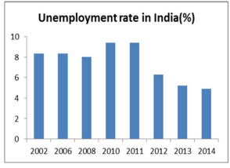

Unemployment Rate in India decreased to 4.9% in 2013 from 5.2% in 2012. It averaged 7.32% from 1983 until 2013, reaching an all time high of 9.4% in 2009 during recession and a record low of 4.9% in 2013 (Ministry of Labour and Employment, India). Youth Unemployment Rate in India decreased to 12.9% in 2013 from 18.1% in 2012. It averaged 15.5% from 2012 until 2013, reaching an all time high of 18.1% in 2012 and a record low of 12.9% in 2013 (Labour Bureau of Government of India).

**CHAPTER 4**

**UNEMPLOYED IN INDIA PIE CHART**

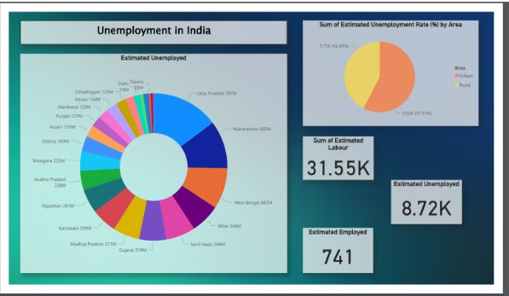

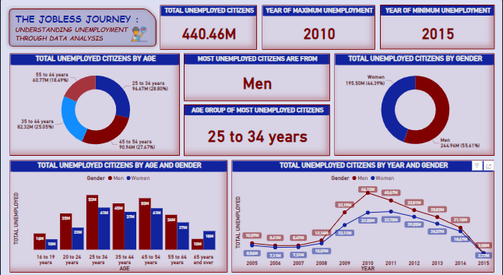

**Details of Unemployment of India:**

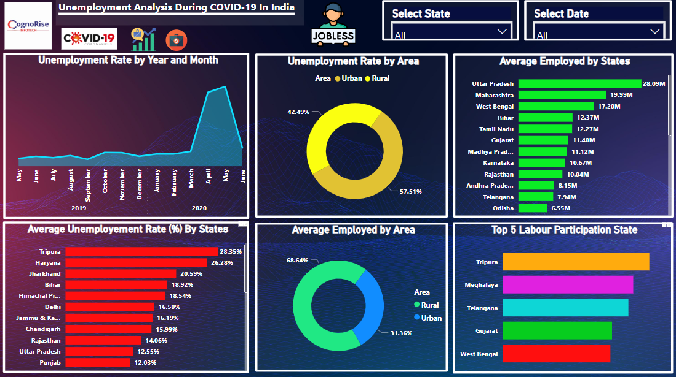

**Dashboard**

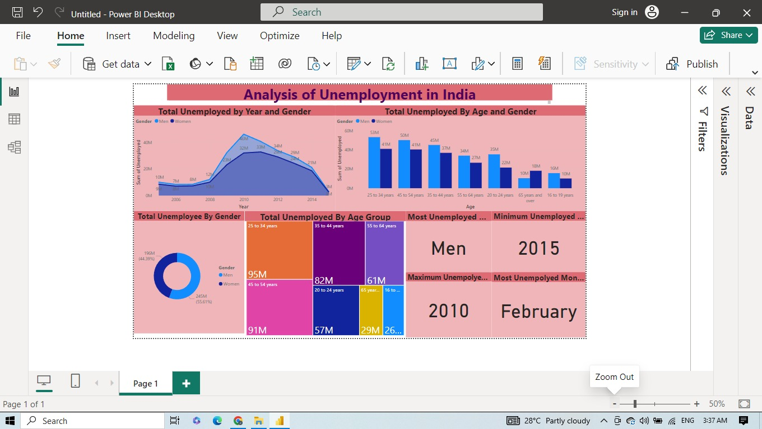

**CONCLUSION**

The unemployment rate in India inched higher to 7.45% in February 2023, taking the total number of unemployed in the country to 33 million. India needs to make dedicated efforts in order to decrease the number of unemployed people.  
  
By following a comprehensive approach including skilling of people, better education, increased focus on labor-intensive sectors, etc. India will be able to decrease the unemployment rate substantially.

**FUTURE SCOPE**

The unemployment rate in India is forecast to 7.38 % in 2024. The unemployment people in India is forecast to 40.22m in 2024.The employment rate in India is forecasted to 51.605 in 2024.The total labor force in India is forecasted to 0.55bn in 2024.

**LINK**